**A TECHNICAL REPORT ON STUDENTS INDUSTRIAL WORK**

**EXPERIENCE SCHEME (SIWES)**

***AT***

**MCLORDS MOBILE SOLUTION LIMITED ADJASCENT RADIO KWARA,**

**GRA, ILORIN, KWARA STATE.**

**PERIOD OF ATTACHMENT: MARCH 2020 – SEPTEMBER 2020**

**BY**

**OLAIFA OLUWASIJIBOMI IBUKUNOLU**

**17/52HA082**

**A REPORT SUBMITTED TO THE DEPERTMENT OF COMPUTER SCIENCE, UNIVERSITY OF ILORIN. KWARA STATE NIGERIA.**

**IN PARTIAL FULFILLMENT OF THE COMPULSORY REQUIREMENT FOR THE AWARD OF B.Sc. IN COMPUTER SCIENCE**

**REPORT OVERVIEW**

This report gives detailed description of the Students Industrial Work Experience Scheme (SIWES), which commenced on the 20th of May 2018, attended on the 3rd of November 2018**McLords MOBILE SOLUTION LIMITED ADJASCENT RADIO KWARA,GRA, ILORIN, KWARA STATE**. The company description is included which comprises various departments of the Establishment with their functions. Also compiled in this report the department where I served at **McLords MOBILE SOLUTION LIMITED**. The SIWES programme has provided a training ground where skills relating to computer operations that is it has provided me knowledge on Computer Engineering. And also provide me with more ideas on the usage of Computer System. This has gone a long way in equipping me in merging what was being taught in the lecture room to what was actually learnt during the SIWES programme.

Table of Contents

CHAPTER ONE 5

INTRODUCTION 5

CHAPTER TWO 7

2.0 DESCRIPTION OF ESTABLISHMENT OF ATTACHMENT 7

2.1 VISION OF THE COMPANY 7

2.2 CORE VALUE 7

2.3 ORGANIZATIONAL STRUCTURE 8

2.4 COMPANY AREA OF SPECIALIZATION 9

CHAPTER THREE 10

3.0 INDUSTRIAL EXPERIENCE 10

3.1HYPER TEXT MARKUP LANGUAGE (HTML) 10

3.2CASCADING STYLE SHEETS (CSS) 11

3.3 BOOTSTRAP 12

3.4 JAVASCRIPT 13

3.5 PHP 13

3.6 MOVIE SEARCH APP 15

Fig 3.6 Display of Movie Search App 15

Fig 3.6.1 Display of Movie Searched Result 16

3.7 SHEFFY’S RESTAURANT WEBSITE 16

Fig 3.7 Display of Sheffy’s Restaurant App 16

Fig 3.7.1 Display of Breakfast Section 17

Fig 3.7.2 Display of Lunch Section 17

3.8 JURASIC PHOTO SEARCH APPLICATION 18

Fig 3.8 Display of Jurasic Photo Search Application 18

Fig 3.8.1 Display of Jurasic Search bar 18

Fig 3.8.2 Display of Jurasic Search Content 19

3.9 CRUD APPLICATION 20

Fig 3.9.1 Display of Crud App Interface 20

Fig 3.9.3 Display of CRUD Database 21

Fig 3.9.4 Display of Edit Post 22

3.9.1 CAR REGISTRATION SYSTEM 23

Fig 3.9.1.1 Interface Of Car Registration Page 23

Fig 3.9.1.2 Database of Car Registration System 24

Fig 3.9.1.3 Display of Registered User Information 24

Fig 3.9.1.4 Display of Print Page 25

CHAPTER FOUR 26

CHALLENGES AND RECOMMENDATION 26

4.0 CHALLENGES 26

4.0 RECOMMENDATIONS 26

CHAPTER FIVE 27

5.0 CONCLUSION 27

# CHAPTER ONE

## INTRODUCTION

In the earlier stage of science and technology education in Nigeria, students wee graduating from their respective institution without any technical knowledge or working experience. It was in this view that students undergoing science and technology related courses were mandated for students in different institution in the view of widening their horizons so as to enable them have technical knowledge or working experience before graduating from their various institutions.

The Student Industrial Work Experience Scheme (SIWES) was established by the industrial Training Fund (ITF) 1973 to enable students of tertiary institution have basic technical knowledge of industrial works base on their course of study before the completion of their program in their respective institutions. It was established to solve the problem of lack of adequate practical skills preparatory for employment in industries by Nigeria graduates of tertiary institutions.

The scheme exposes students to industry based skills necessary for a smooth transition from classroom to the world of work. It affords students of tertiary institutions the opportunity of being familiarized and exposed to the needed experience in handling machinery and equipment which are usually not available in the educational institutions.

One of the primary goals of the SIWES is to help students integrate leadership development into experiential learning process. Students are expected to learn and develop basic non-profit leadership skills through a mentoring relationship with innovative non-profit leaders.

The major benefits accruing to students who participate conscientiously in Students Industrial Work Experience Scheme (SIWES) are the skills and competencies they acquire. The relevant production skills remain a part of the recipients of industrial training as life-long assets which cannot be taken away from them. This is because the knowledge and skills acquired through training area internalized and become relevant when required to perform jobs or functions.

Participation in SIWES has become a necessary pre-condition for the award of Diploma and Degree certificates in specific disciplines in most institutions of higher learning in the country, in accordance with the education policy of government.

Operators – The ITF, the coordinating agencies (NUC, NCCE, NBTE). Employers of labour and the institutions Funding – The Federal Government of Nigeria.

**1.1 OBJECTIVES**

The Industrial Training Fund’s policy Document No.1 of 1973 which established SIWES outlined the objectives of the scheme. The objectives are as follows:

* Prepare students for industrial work situations that they are likely to meet after graduation.
* Provide an avenue for students in higher institutions of higher learning to acquire industrial skills and experiences during their course of study.
* Expose students to industrial work methods and techniques in handling equipment and machinery that may not be available in their institutions.
* Make the transition from school to the world of work easier and enhance students contact for later job placements.
* Provide students with the opportunities to apply their educational knowledge in real work situations, thereby bridging the gap between theory and practice.
* Enlist and strengthen employers’ involvement in the entire educational process through SIWES
* To expose students to latest developments and technological innovations in their chosen professions.

# CHAPTER TWO

## 2.0 DESCRIPTION OF ESTABLISHMENT OF ATTACHMENT

McLords Mobile Solution Limited has history of creativity and innovation in the simulation of clients. Since inception, they have remained focus on delivery quality I.T solution and training to their clients. Year after years, McLords Mobile Solution Limited has refined her quality process, focusing on course development, instructor training and facility expansion. This is to ensure the training investment will produce the desire results.

## 2.1 VISION OF THE COMPANY

They have turned out quite an impressive number of students performing well both in Government and private establishments within and outside the country. They tailor their training program to meet the needs of individual clients according to their professional background, Tier track record can speak for them. McLords Mobile Solution Limited is an ICT firm registered in Nigeria to provide ICT related Services.

McLords Mobile Solution Limited was registered by corporate affairs commission in 2009. The company has its head office at Georgia in USA, one branch at Ikeja, Lagos State and another branch at GRA in Ilorin.

The company has implemented several project that covers.

* Banking Application for micro-finance bank.
* Payroll for government parastatals.
* They also provide solution for event ticketing, transportation, restaurant, hotels etc

## 2.2 CORE VALUE

The strength of our company lies in our Human Resources which are continually rejuvenated by bringing in more hands which can make us live up to our name by being the foremost software development company in Nigeria. Leveraging current technology to provide simple solution to complex processes.

## 2.3 ORGANIZATIONAL STRUCTURE

MANAGING DIR.

DIRECTOR I.T PROJECT

INSTRUCTOR P.M

INSTRUCTOR ON SIWES ASPECT

SECRETARY

WEB DEVELOPMENT

COMPUTER HARDWARE

SOFTWARE DEV.

DATA MINING

## 2.4 COMPANY AREA OF SPECIALIZATION

There are various Departments/Units namely;

1. **ENGINEERING DEPARTMENT**

The computer engineering department deals with the maintenance, repair and upgrading of computer system.

1. **SOFTWARE DEVELOPMENT DEPARTMENT**

Software Development Department deals with computer programming, documenting, testing, and dug fixing involved in creating and maintaining application and frame work resulting in a software product.

1. **DATA MINING DEPARTMENT**

This department deals with computing process of discovering patterns in large data sets involving methods at the intersecting of machine learning, statistics, and database system. However the overall goal of the data mining process is to extract information from a data set and transform it into an understandable structure for further use.

1. **WEB DEVELOPMENT DEPARTMENT**

These department deals with designing a website for the internet (World Wide Web) or an intranet (a private network). Web development can range from developing the simplest static single page of plain text to the most complex web-based internet application (or just ‘web apps”) electronic businesses and social network service.

# CHAPTER THREE

## 3.0 INDUSTRIAL EXPERIENCE

**WEB DEVELOPMENT DEPARTMENT**

This department was where my industrial training took place , I was exposed to the world of web development especially through creation of websites taking me step by step with pratical all through the process.During six month of the SIWES training I was able to acquire much knowledge on web development.I was able to use HTML5,CSS,Bootstrap4, Javascript and Php to achieve some tasks during this time.

## 3.1HYPER TEXT MARKUP LANGUAGE (HTML)

Hypertext markup language (HTML) is the backbone of any website development process, without which a web page doesn't exist. Hypertext means that text has links, termed hyperlinks, embedded in it. When a user clicks on a word or a phrase that has a hyperlink, it will bring another web-page. A markup language indicates text can be turned into images, tables, links, and other representations. It is the HTML code that provides an overall framework of how the site will look.

**Below is an example of HTML used to define a basic webpage with a title and a single paragraph of text**

<!DOCTYPE html>

<html>

<head>

<meta charset =”UTF – 8”

<title>About Report</title>

</head>

<body>

<p> Hello this is my SIWES Report </p>

</body>

</html>

The first line defines what type of contents the document contains. "<!DOCTYPE html>" means the page is written in HTML5. Properly formatted HTML pages should include <html>, <head>, and <body> tags, which are all included in the example above. The page title, metadata, and link to referenced files are placed between the <head> tags. The actual contents of the page go between the <body> tags.

The web has gone through many changes over the past few decades, but HTML has always been the fundamental language used to develop web pages. Interestingly, while websites have become more advanced and interactive, HTML has actually gotten simpler. If you compare the source of an HTML5 page with a similar page written in HTML 4.01 or XHTML 1.0, the HTML5 page would probably contain less code. This is because modern HTML relies on cascading style sheets or JavaScript to format nearly all the elements within a page.

## 3.2CASCADING STYLE SHEETS (CSS)

CSS stands for "Cascading Style Sheet." Cascading style sheets are used to format the layout of [Web pages](https://techterms.com/definition/webpage). They can be used to define text styles, table sizes, and other aspects of Web pages that previously could only be defined in a page's [HTML](https://techterms.com/definition/html).

CSS helps Web developers create a uniform look across several pages of a Web site. Instead of defining the style of each table and each block of text within a page's HTML, commonly used styles need to be defined only once in a CSS document. Once the style is defined in cascading style sheet, it can be used by any page that references the CSS file. Plus, CSS makes it easy to change styles across several pages at once. For example, a Web developer may want to increase the default text size from 10pt to 12pt for fifty pages of a Web site. If the pages all reference the same style sheet, the text size only needs to be changed on the style sheet and all the pages will show the larger text.

While CSS is great for creating text styles, it is helpful for formatting other aspects of Web page layout as well. For example, CSS can be used to define the cell padding of table cells, the style, thickness, and color of a table's border, and the padding around images or other objects. CSS

gives Web developers more exact control over how Web pages will look than HTML does. This is why most Web pages today incorporate cascading style sheets.

## 3.3 BOOTSTRAP

Bootstrap is a framework to help you design websites faster and easier. It includes HTML and CSS based design templates for typography, forms, buttons, tables, navigation, modals, image carousels, etc. It also gives you support for JavaScript plugins. The basic file structure looks like this:

bootstrap/

├── css/

│ ├── bootstrap.css

│ ├── bootstrap.css.map

│ ├── bootstrap.min.css

│ ├── bootstrap-theme.css

│ ├── bootstrap-theme.css.map

│ └── bootstrap-theme.min.css

├── js/

│ ├── bootstrap.js

│ └── bootstrap.min.js

└── fonts/

├── glyphicons-halflings-regular.eot

├── glyphicons-halflings-regular.svg

├── glyphicons-halflings-regular.ttf

├── glyphicons-halflings-regular.woff

└── glyphicons-halflings-regular.woff2

The Bootstrap structure is pretty simple and self-explanatory. It includes precompiled files that enable quick usage in any web project. Besides compiled and minified CSS and JS files, it also includes fonts from [Glyphicons](http://glyphicons.com/), and the optional starting Bootstrap theme.

This structure can be easily incorporated in your own project’s file structure by just including the Bootstrap files exactly as they come out of the zip archive, or if it suits your project better, you can rearrange these files and place them anywhere you like. Just be sure that the Glyphicons fo nts folder is on the same level as the CSS folder

## 3.4 JAVASCRIPT

JavaScript is a scripting or programming language that allows you to implement complex features on web pages every time a web page does more than just sit there and display static information for you to look at displaying timely content updates, interactive maps, animated 2D/3D graphics, scrolling video jukeboxes, etc.You can bet that JavaScript is probably involved. It is the third layer of the layer cake of standard web technologies, two of which (HTML and CSS)

## 3.5 PHP

PHP is a server scripting language, and a powerful tool for making dynamic and interactive Web pages.

PHP is a widely-used, free, and efficient alternative to competitors such as Microsoft's ASP.

Instead of lots of commands to output HTML (as seen in C or Perl), PHP pages contain HTML with embedded code that does "something" (in this case, output "Hi, I'm a PHP script!"). The PHP code is enclosed in special start and end processing instructions <?php and ?> that allow you to jump into and out of "PHP mode."

What distinguishes PHP from something like client-side JavaScript is that the code is executed on the server, generating HTML which is then sent to the client. The client would receive the results of running that script, but would not know what the underlying code was. You can even configure your web server to process all your HTML files with PHP, and then there's really no way that users can tell what you have up your sleeve.

The best things in using PHP are that it is extremely simple for a newcomer, but offers many advanced features for a professional programmer.

**Below is an example of PHP used to define a basic webpage**

<!DOCTYPE html>  
<html>  
<body>  
  
<?php  
echo "My first PHP script!";  
?>  
  
</body>  
</html>

## 3.6 MOVIE SEARCH APP

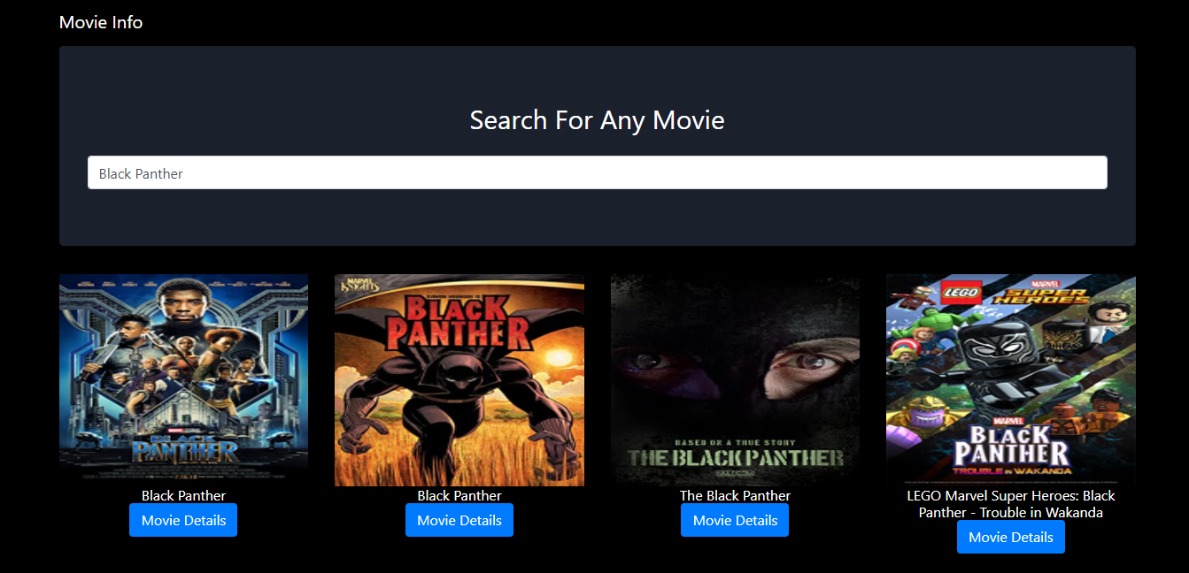

### Fig 3.6 Display of Movie Search App

Movie Search App is a web app were you can search for any movie you wish and you get the details of the movie such as the Genre,plot and you can view the IMDB rating.

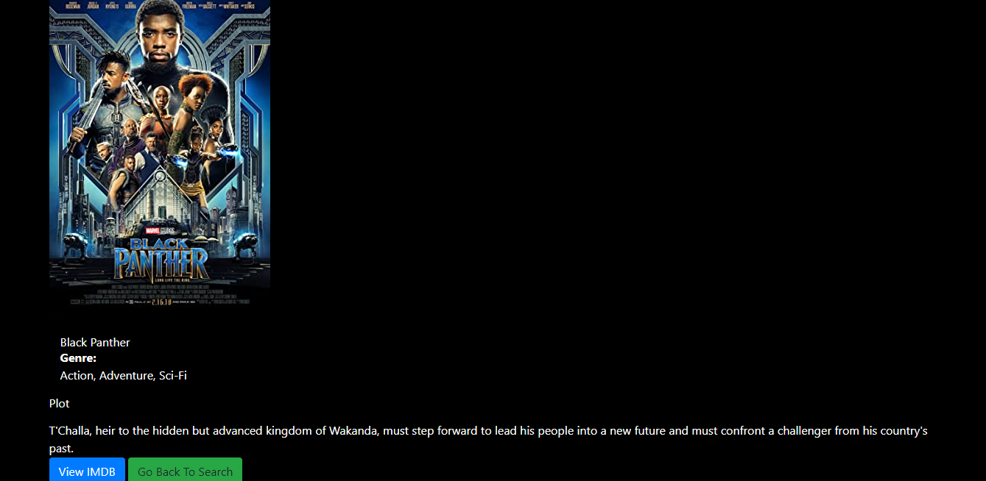

### Fig 3.6.1 Display of Movie Searched Result

**Purpose of Movie App:**

The main purpose of Movie App is to create a more easier platform for users to be able to search for any movie of their choice.

## 3.7 SHEFFY’S RESTAURANT WEBSITE

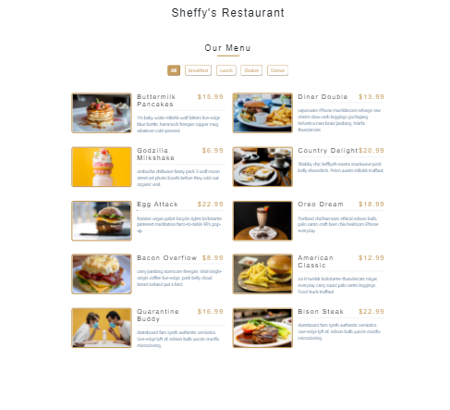

### Fig 3.7 Display of Sheffy’s Restaurant App

Sheffy’s Restaurant website is a website which shows all the available foods in the restaurant for users to buy.In the Menu there are different sections such as Breakfast,Lunch,Shakes and Dinner where user can select different varieties of food through the use of Javascript as shown below

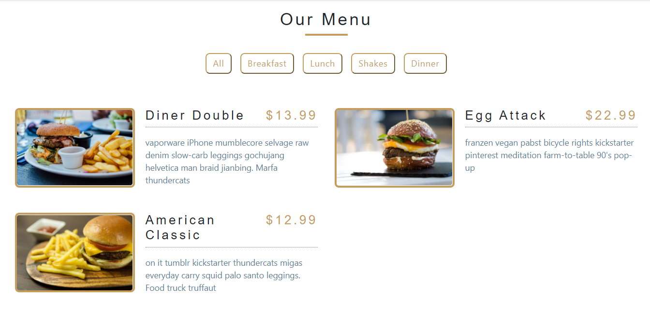

### Fig 3.7.1 Display of Breakfast Section

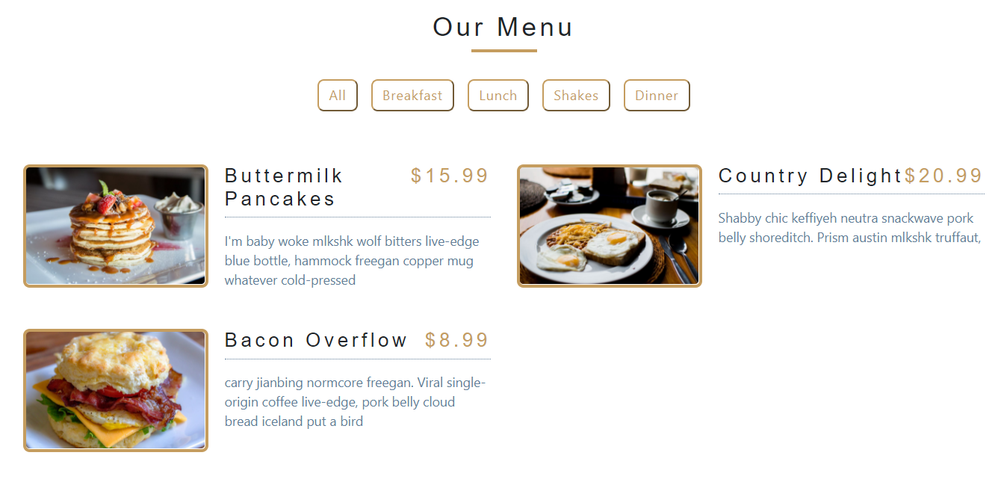

### Fig 3.7.2 Display of Lunch Section

**Purpose of Sheffy’s Restaurant:**

The main purpose of Sheffy’s Restaurant is to make the Restaurant menu available via any electronic devices instead of the normal manual menu. Through this website the menu can be available at any time.

## 3.8 JURASIC PHOTO SEARCH APPLICATION



### Fig 3.8 Display of Jurasic Photo Search Application

Jurasic Photo Search Application is an application which is used to search for animal pictures.This application made use of JQUERY to consume an API and send the request through a json format to get the images of any animal searched displayed.



### Fig 3.8.1 Display of Jurasic Search bar

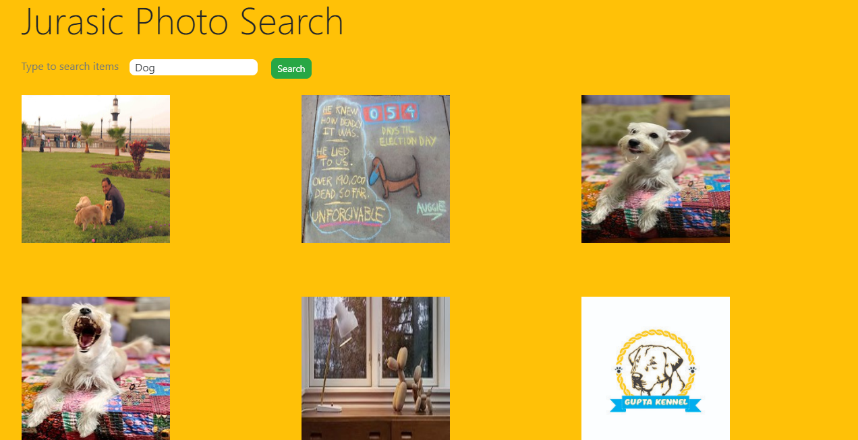

### Fig 3.8.2 Display of Jurasic Search Content

**Purpose of Jurasic Photo Search:**

The purpose of Jurasic Photo Search is to help users get any picture of any animal user wish to get.

## 3.9 CRUD APPLICATION

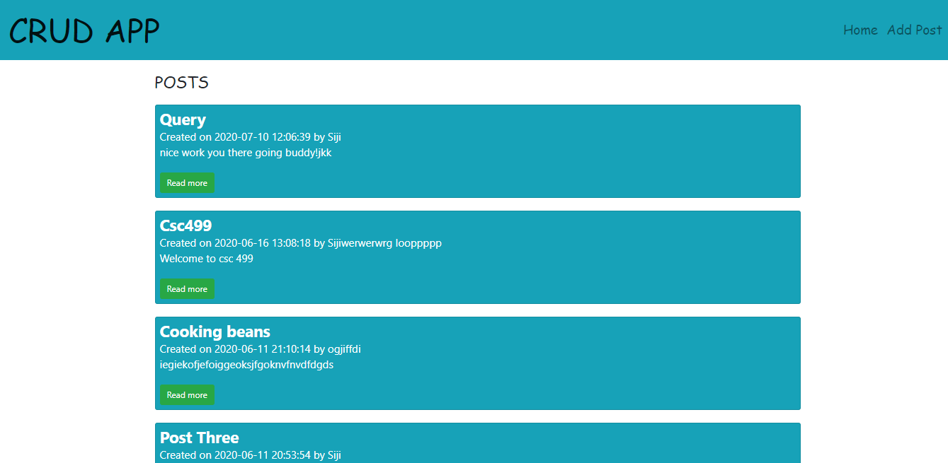

### Fig 3.9.1 Display of Crud App Interface

CRUD is an abbreviation for Create, Update and Delete. This application enables user to create a post in which post has a form which consist of the title of the post,body of the post and author of the post.

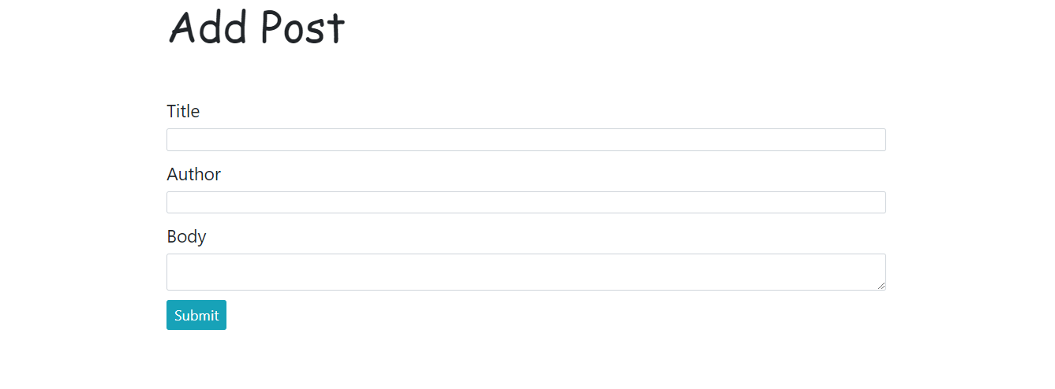Fig 3.9.2 Display of Add Post

After the user has written a post and click the submit the post get submitted into the database in which there is a post table inside the database assigned to the CRUD application databases.

The database used here is MYSQL . A database called “myphpblog” was created with a table called “posts” which consists four columns which are id,title,author,body and created_at.Each Posts submitted by the user get into the posts table and go the each assigned column.

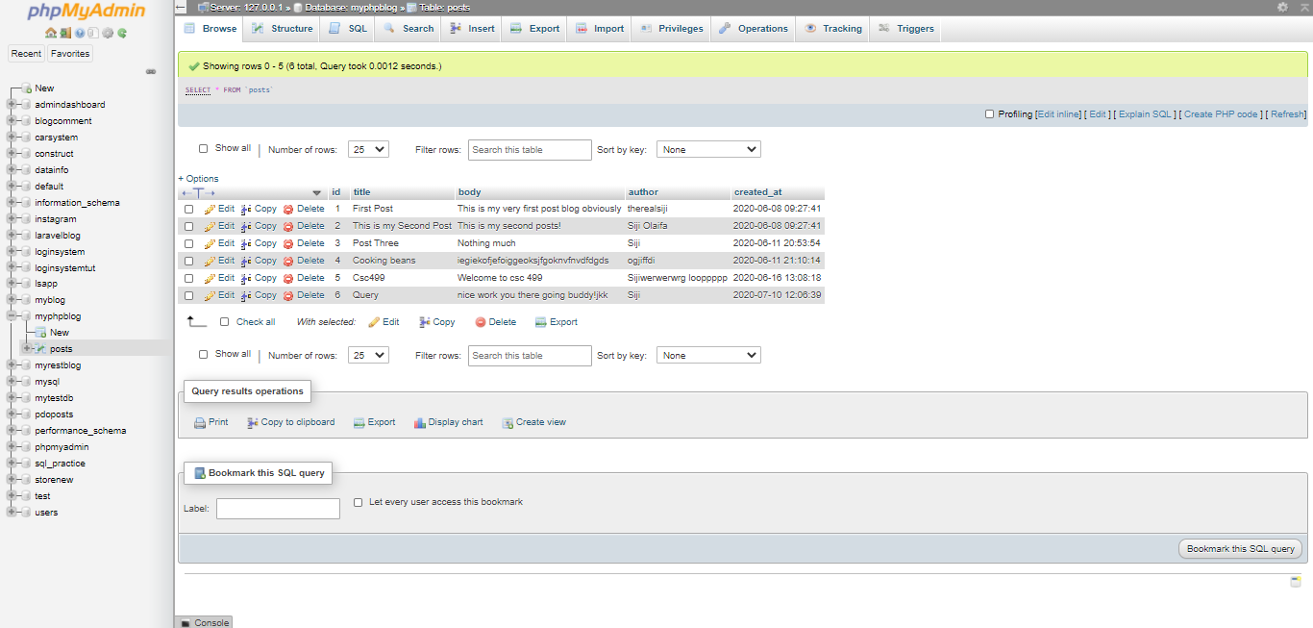

### Fig 3.9.3 Display of CRUD Database

Furthermore if the user want to edit a post,the user will click on the edit button to implement the edit feature.The edit feature has a form which will show the initial information put in by the user.

The delete feature can also be seen when user select any of it initial post

as shown below

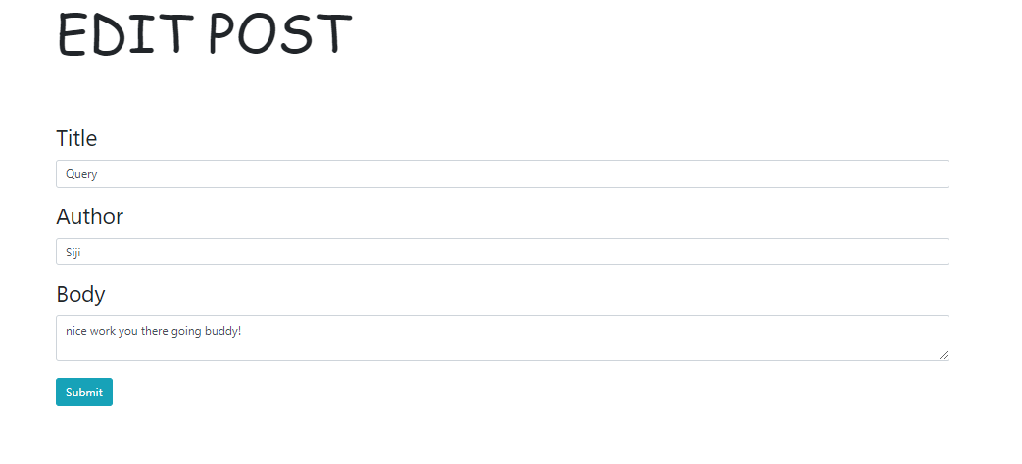

### Fig 3.9.4 Display of Edit Post

**Purpose CRUD APPLICATION:**

The main purpose of the CRUD Application is provide a platform where user can write a post ,view the post ,edit the post and delete the post when needed.

# 3.9.1 CAR REGISTRATION SYSTEM



### Fig 3.9.1.1 Interface Of Car Registration Page

Car Registration System is a platform where user can register information about their car and get it printed after registration.

MYSQL database was used in this application and a car system database was created along with a table called “users” where the input field such as Full name,car plate number,phone number,next of kin,car color,car chassis number,next of kin phone number,car color,car model and image from the registration form get submitted into the database table.

In the the registration there is an input field called “image” the user have put in his/her image for the purpose recognition and it get parsed into the database.

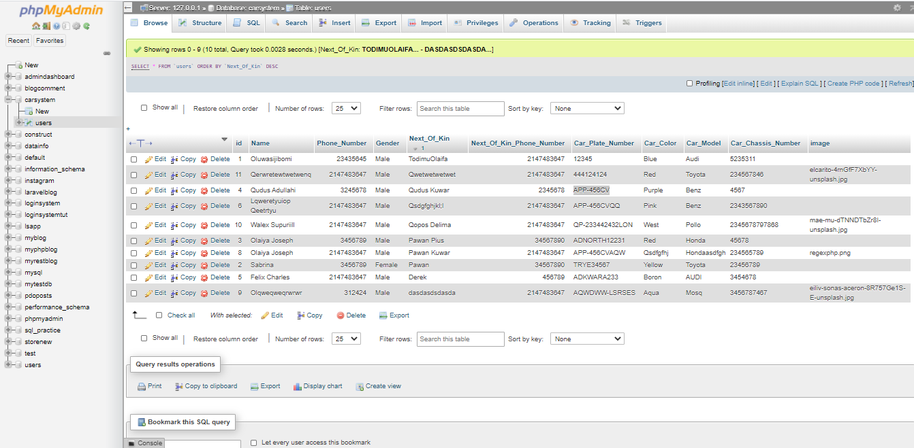

### Fig 3.9.1.2 Database of Car Registration System

In the home page the user can search by Place Number in the search textbox and the user car information get displayed

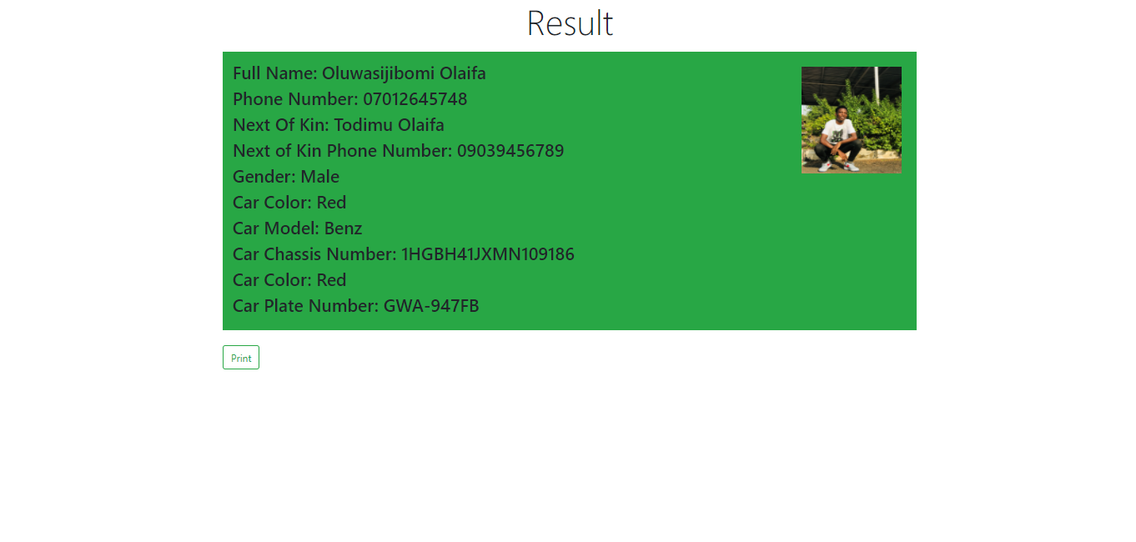

### Fig 3.9.1.3 Display of Registered User Information

When the user click print this page get displayed

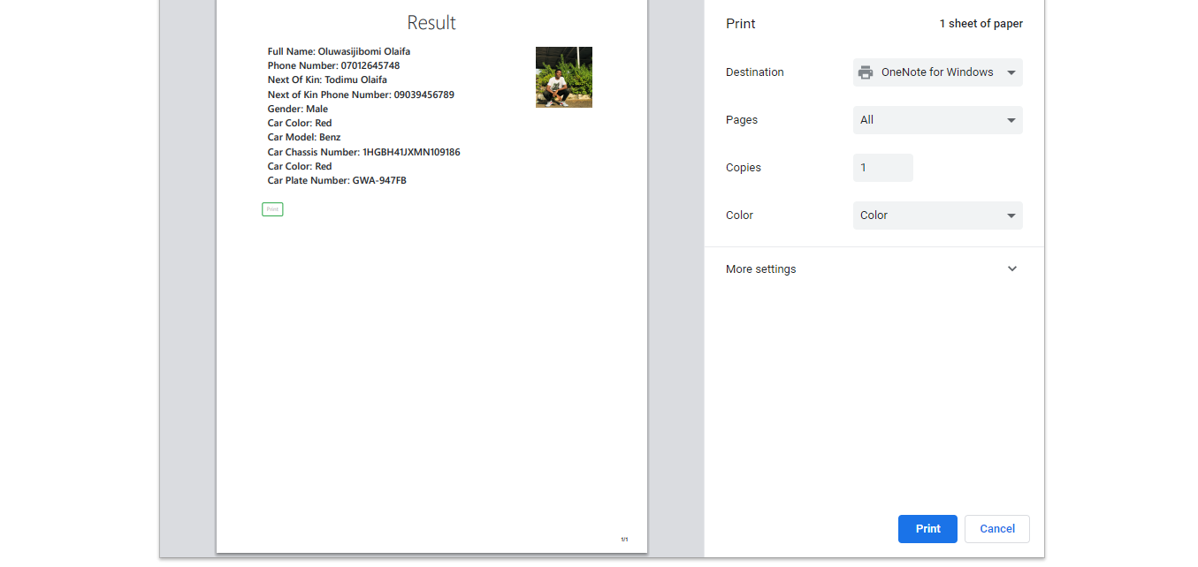

### Fig 3.9.1.4 Display of Print Page

# CHAPTER FOUR

## CHALLENGES AND RECOMMENDATION

### 4.0 CHALLENGES

**●** Difficulty in seeking for IT placement.

**●** I was not paid in my place of attachment.

**●** One of my major problem was the inavailability of internet access. Internet access was a major challenge for me because I make use of internet everyday anytime I encounter an error I have to check my browser and look for the solution to my problems.

### 4.0 RECOMMENDATIONS

**●** School should provide a place of attachment for student.

**●** Allowance should be paid to students during the programme and not after.

**●** Supervisor should visit student in their various place of attachment.

**●**  The ITF also should ensure that the payment of the student allowance is paid on time in other to keep the SIWES students zealous and motivated.

**●**  I recommend that the Nigerian educational system should be reviewed as what is taught in the classroom totally contradicts with what is needed the in the actual work place.

# CHAPTER FIVE

## 5.0 CONCLUSION

My six months Industrial Training at MCLORDSS MOBILE SOLUTION LIMITED was a huge success and a great time of acquiring new skills.During my training I was able to appreciate the aspect of web development more because I was able to set a goal for myself to build some applications. SIWES as a course has truly exposed me to the challenges faced in a growing I.T world that is dependent on programming.